Regrooving of truck and bus tyres
Applicable Regulations
Construction and Use Regulations 24 and 27 apply. Only tyres identified on the sidewall as regroovable may legally be regrooved. This applies to both new and retreaded tyres. It is also a legal requirement that any regrooving must follow the pattern specified by the manufacturer. If the tyre cords are exposed as a result of regrooving the tyre is no longer legal and must be withdrawn from service.
Basic principles
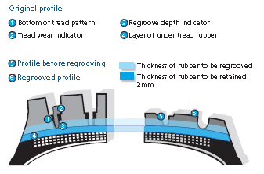
The regrooving operation consists of cutting into the tread of a tyre a tread pattern deeper than the original, so as to prolong the tyre’s useful life. When regrooving, it is of fundamental importance to avoid exposing the upper belts of the tyre, and to ensure that an adequate layer of rubber is left to protect them. Tyre manufactures supply specific instructions regarding the patterns and procedures to follow in the regrooving of tyre treads. These include recommended groove widths and the depth of rubber to remove from the base of the original grooves.
Regrooving should normally be carried out on the entire tread according to the recommended pattern and procedure. However, where a tyre has worn abnormally, it may be possible to regroove just that part of the worn tyre, provided a sufficient portion of the original groove is visible before regrooving. Clearly, this precludes further re-grooving later in the tyre’s life.
Manufacturer’s regrooving patterns
Click on the hyperlinks below to access the manufacturer’s guidance and regrooving patterns.
Bridgestone | Continental | Dayton
Firestone | GT Radial | Goodyear Dunlop
Hankook | Michelin | Pirelli

